Data Mining Project

Predicting Music Subscription Churn
&
Recommending Churn Prevention Marketing Strategy



ISM 6136 – Data Mining
Professor: Dr Balaji Padmanabhan

University of South Florida

Tampa, Florida

GROUP 9:
AMITHA RAJAPPA
LUCKY HIRANI
PRACHI GUPTA
RAO RANDHIR SINGH
Table of Contents

Introduction 3
Business Problem 3
Business Objectives 3
Methodology 3
Pre-processing 3
Use-Case 1- Methodology and Output Analysis 6
Use-Case 2- Methodology and Output Analysis 7
Use-Case 3- Methodology and Output Analysis 8
Conclusion 10
Future Use Cases 10

Introduction

Business Problem
The case is of a leading company which provides music streaming services. They offer services on pay per month model as well as for free. The revenue model of the company is highly dependent on converting their free service users (treats them as the potential customer base) into paid users and also prevent their existing, paid service customers from churning and switching to a competitor service provider. The switching cost for these customers is very low and in turn, the service providers, they switch/may switch to, have very low entry barrier for entering this industry.

Business Objectives
The company has a database which keeps records of customers who are churned and who are not churned. It intends to analyze the key metrics which caused these churns and come up with tweaks in its service offerings to retain such customers. This is very important as the cost of acquiring new customers is much higher than retaining the existing customer base. It aims at:

- Classifying customers based on their probabilities to churn.
- Identifying key metrics that drive customers’ loyalty to the company
- Tweaking the existing/pitching relevant services to the potential (currently availing the free service/s) as well as the current, paid customers in order to retain them.

Methodology

To achieve the business objectives above, predictive modeling techniques are used to identify customers who were likely to churn or who were likely to continue. Various predictive models are used (Please refer section -- for details), their performances are compared and the best among them is chosen based on its accuracy and explaining abilities.

Pre-processing

The company’s dataset had more than a million rows. SEMMA (Sample, Explore, Modify, Model and Assess) method is followed to obtain a sample of dataset where:
- We have used Power BI, Excel Data modelling tools to query the dataset, to remove the unwanted columns and to merge the required columns in a single sheet dataset.
- To take out a sample out of this reduced dataset, we have applied a few rules such as:
  - Only the Cases of customers who are churned/not churned are being taken. Any other value (N/A or empty in this case) is ignored.
  - For the field, ‘Membership Expiry Date’, where the values are N/A or empty, are ignored.
  - Apart from the above, any missing values in every other column are imputed and are replaced with the ‘mean’ value of the entire column.
  - For the input variable, age (bd column in the dataset), it had outliers like age values more than 103 yrs, which are unrealistic values. These values were imputed and replaced with the ‘mean’ value of the entire age (bd) column.
- The sample thus obtained has 23188 rows and 23 columns where, 22 columns are used as the input variables and there is one target variable, IS_CHURN whose value is being predicted. The description of the variables is as follows:
  - Msno: User ID, unique identifier for each customer
  - Payment_method_ID: Payment method type
  - Payment_Plan_Days: Length pf paid membership in days
  - Plan_list_price: Price paid for the subscription
  - Actual_amount_paid: The amount paid against the indicated Plan_list_price
  - Is_auto_renew: Is the membership auto renewable or the customer needs to do it, indicated by values 1 and 0 respectively
  - Transaction_date: Date when the corresponding customers made the transaction. Replaced with ‘Column2’, with date format changed to MM/DD/YYYY
  - Membership_expire_date: Date when the subscription ends. Replaced with ‘Column3’ with date format changed to MM/DD/YYYY
  - Is_Cancel: Indicates if the customer canceled the membership or not (represented by 1 and 0 respectively). A value of 1 does not necessarily indicate that the customer churned
  - Num_25: Number of songs played for less than 25% of the song length
  - Num _50: Number of songs played between 25% o and 50% of the song length
  - Num _75: Number of songs played between 50% and 75% of the song length
  - Num _985: Number of songs played between 75% & 98.5% of song length
  - Num _100: Number of songs played for over 98.5% of the song length
  - Num _unq: Number of unique songs played
  - Total_secs: Total seconds played
  - Bd: Age of the customers
  - Gender: Indicates if the customer is a male or a female
  - City: Indicates a list of 11 cities across the country from where the corresponding customers subscribed
  - Registered_via: Channels/modes from which customers subscribe
  - Registration_init_time: The date when the customer signed for the services of the company. Replaced with ‘Column1’ after changing the date format to MM/DD/YYYY
  - Is_Churn: Binary, target variable. A value of 0 indicates that the customer has not churned and a value of 1 for this variable indicates that the corresponding customer has churned.
  - Derived Variables: Additionally, we have derived 2 new variables from the above dataset and their description is as below:

    - Time on Board: It is obtained in ‘number of days’ by subtracting the ‘Registration_Init_Time’ from ‘Membership_expire_date’. This provides the number of days for which a customer’s subscription was alive. The column’s values have been used in further analysis of the case (Please refer section -- for more details)
    - Loyalty: Ranges from values 1 (representing the least loyal customer) to 5 (representing the most loyal customer). The scores are assigned based on calculations made through a decision tree on the most ‘worth’ or ‘significant’ variables (Please refer section -- for further details).
    - The most ‘worth’ or ‘significant’ variables are obtained as below:

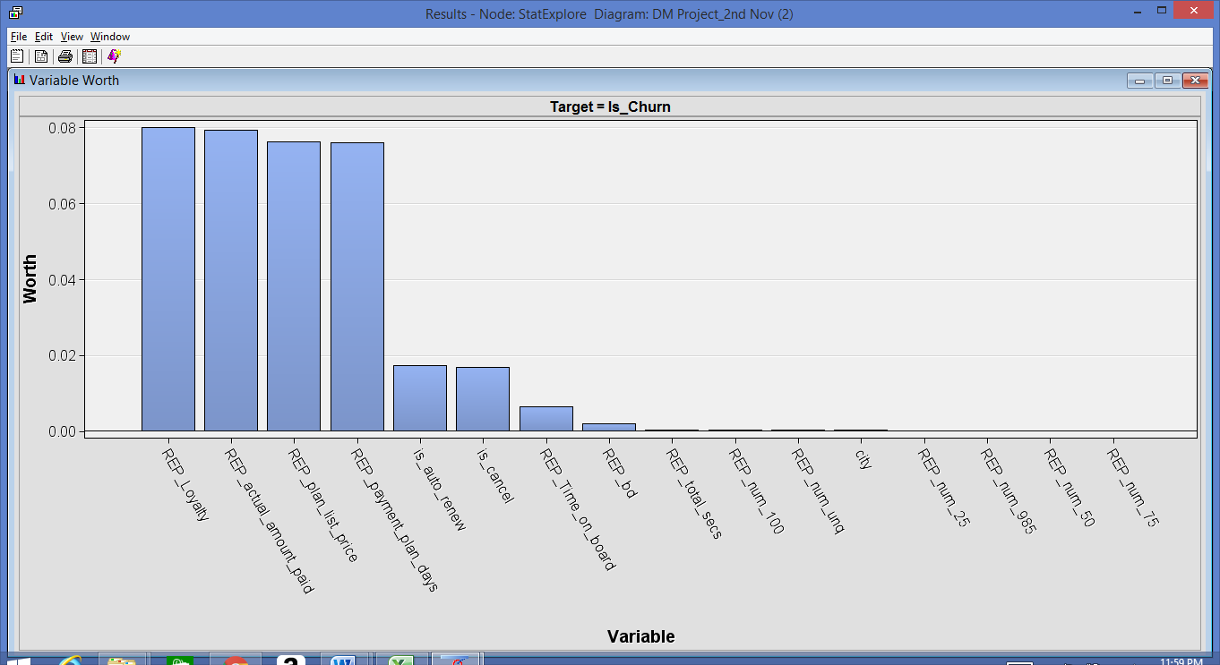
The figure above shows that variables (Loyalty, actual_amount_paid, plan_list_price, payment_plan_days, Is_auto_renew, Is_cancel, Time _on _Board and Age (bd) explain for almost 100% of the variances in the values of target variable, Is_Churn.

Use-Case 1- Methodology and Output Analysis

Description: Churn Prediction- Classifying customers based on their probabilities to churn.

We wanted to build a predictive model in order to predict the customer churn. The main idea to get this prediction data was to analyze the factors that had been highly affecting the churn. We chose to build Decision tree model in order to understand the basis on which the tree has been split. In order to optimize its output the decision tree was pruned to avoid outliers
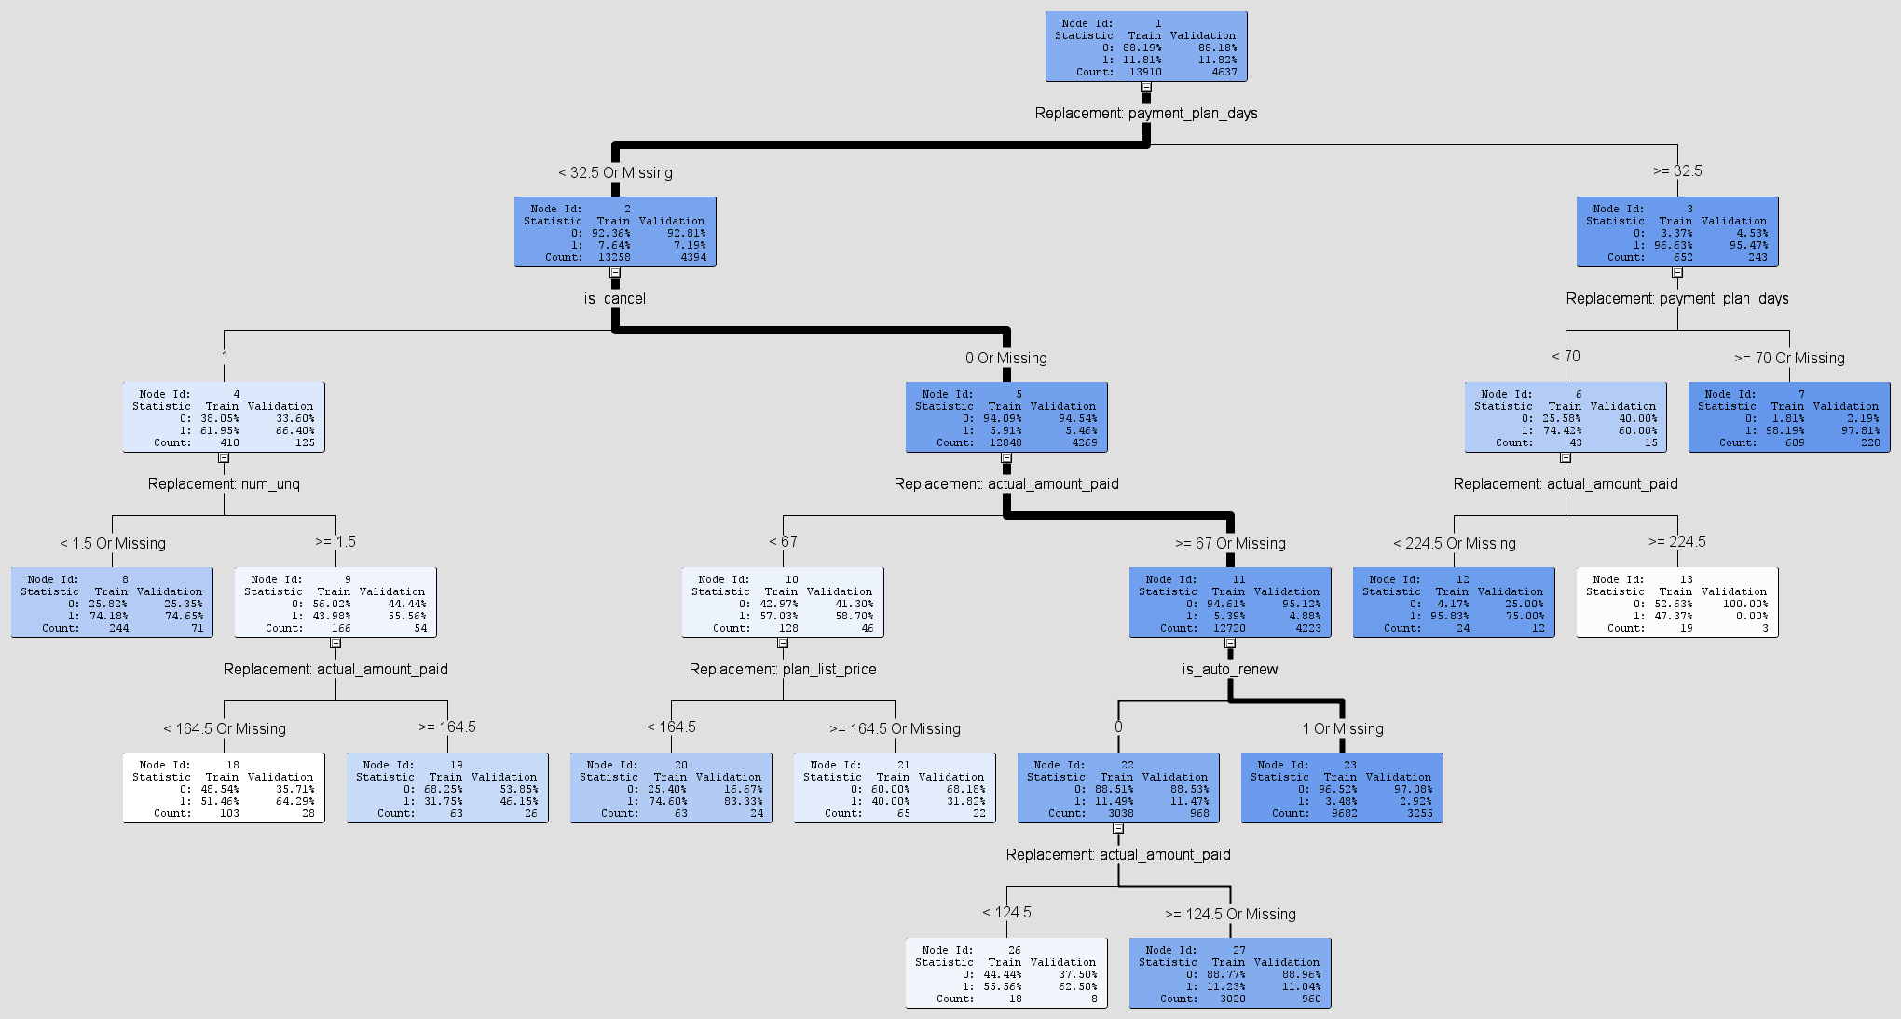
From the above output of the Decision Tree we could determine the following significant rules that we would use to further factor the important factors leading to churn wherein payment plan days, actual amount paid etc. are a part of the splitting. We will further investigate these variables for future recommendations.
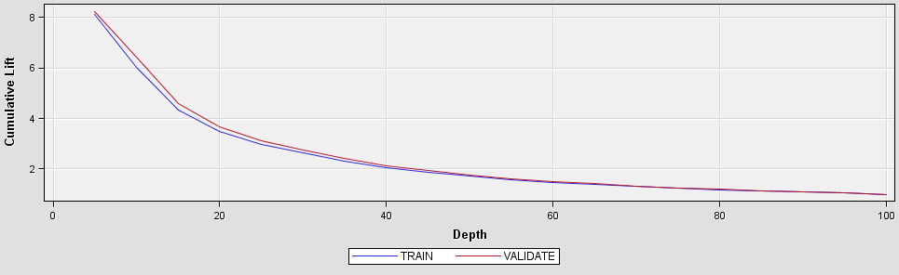
Data Role=VALIDATE Target=Is_Churn Target Label=Is_Churn
False True False True
Negative Negative Positive Positive
220 4046 43 328
As per the above diagrams, it can be clearly seen that the Decision tree model has a good confusion matrix over the validation dataset where the true positive and true negative rate are substantially high than the false positive and false negative rate. The model achieves a misclassification rate of 5%.

Use-Case 2- Methodology and Output Analysis

Description: Clustering- Identifying key metrics that drive customers’ loyalty.

Our next objective was to cluster the similar customers and determine the clusters to which these customers belong. We used K means clustering with number of clusters set to 4.
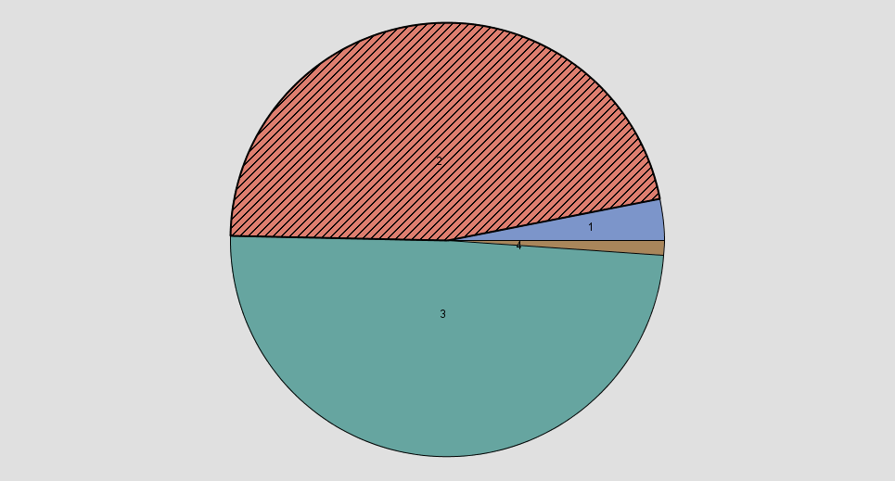
As from the cluster partitioning, it can be seen that majorly the customers are divided into cluster 2 and 3.
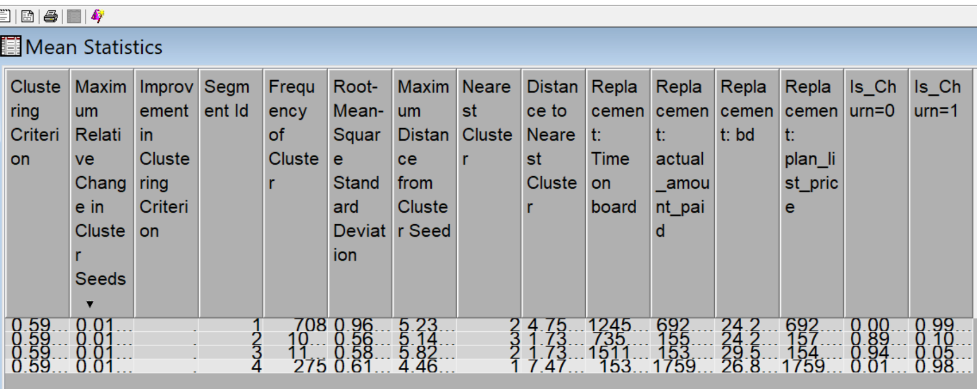
As from the above cluster, we further divided the customers into the following four categories and have been assigned a loyalty score of 1 to 5:

Category5- Highly Loyal: Highly Engaged and maximum revenue generating segment.
Category4- Moderately Loyal: Highly engaged and significant revenue generating segment.
Category3- Loyal: Most engaged customers but are not significant revenue contributor.
Category2 & Category1- Disloyal: Least engaged & have minimum contribution to revenue.

The splitting rules in the decision trees are combined with the clustering that is done above will be further used to determine the recommendations to the customer as will be explained in next section.

Use-Case 3- Methodology and Output Analysis

Description - Recommendation Engine to avoid Customer Churn:
Tweaking the existing/pitching relevant services to the potential (currently availing the free service/s) as well as the current, paid customers in order to retain them.

A major concern for businesses is to retain customers and promote customer value and provide them with services which helps them to institute a long-term relationship with customers. Beyond using the Machine Learning Algorithms to predict the customer churn rate, we have come up with a recommendation system to suggest a subscription plan to a customer which is about to churn.

In this recommender model, we have applied the User based Collaborative filtering. With this model, once the churners are identified, we recommend the right product subscription plan to them which can therefore prevent them from churning.

Methodology:

The overall idea that we have used to come up with the recommendation engine is as follows. The current set of attributes for each customer were used to come up with a score called ‘Loyalty’ which ranges from 1 to 5 for every customer; 1 being the least loyal customer and 5 being the most loyal customer. The method used to arrive the ‘Loyalty’ score is as below.
We sought out the significant variables from the dataset, and created a decision tree on these significant variables, then we considered the leaf nodes and created rules on those conditions to assign a loyalty score in the range of 1 to 5 to the customers, where 5 being the highly loyal customer.
Once we have the clusters for churned and non-churned customers using the method described in Use-Case 2, for each customer having a less loyalty score, we find the nearest loyal customer and look up for the loyal customer’s subscription plan and suggest this to the customer with the less loyalty score. This way, we can make a recommendation to a less loyal customer, have him subscribe to plan and retain that customer.

Model Implementation:

We used Microsoft Azure ML Studio to come up with the Recommender system as in first figure shown below. The attributes used to train the Recommender model are the msno, plan_price, loyalty. The payment_plan_price and plan_days attributes were used as the item attributes to score the recommender model. We set the number of recommendations to 5, since we can find the closest loyal customer in our case. The result of this model will be the nearest customer whose id can be looked me for his subscription plan and recommend that to the less loyal customer. The results are indicated in figure 2 as shown below.

Decision Tree:
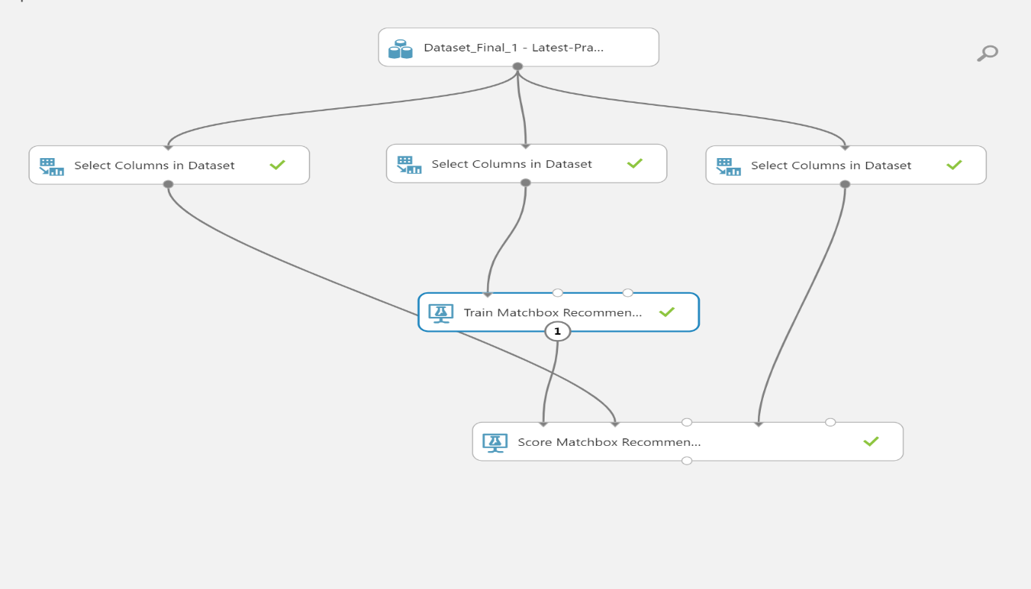

Similar Users:
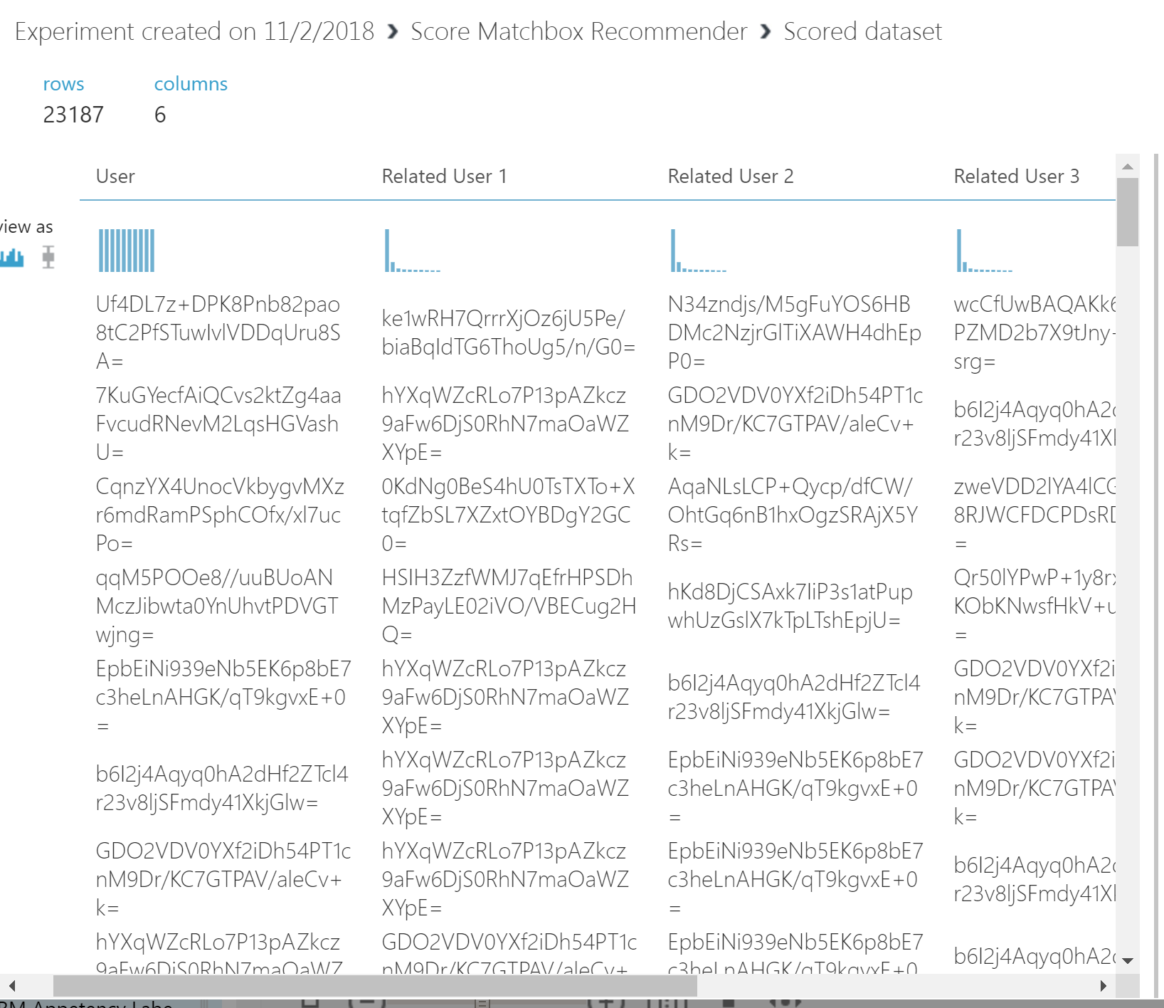

Conclusion

We have tried to predict the churn in the music subscription, by using the data mining techniques such as Decision tree in SAS Miner to understand the significant variables and to capture the loyalty category. By capturing the loyalty categories of the user and by understanding the attributes that create a difference between the loyalty levels of each customer using clustering in our sampled data, we have created a recommendation model in Microsoft Azure. The recommendation model analyses the nearest customer who hasn’t churned and is loyal to the company, we are then able to recommend that user’s subscribed plan to other users who are likely to churn. This ensemble of our models helps us in achieving our objectives of classifying the customers and predicting the churn and then preventing by providing right plans to the customers.

Future Use Cases

- We can create a recommendation system of similar users on any other parameters such as Subscription Days, Age etc.
- Recommendation based on Songs Category: We can use song dataset, which gives the songs that a user has heard and the category of those songs, a recommendation system of songs can be made by understanding the category preferences of users and by taking out similar users based on that. This can help in recommending a new category of songs to the users.
- Learning the songs’ features (such as Rhythm, beat etc.) and providing the recommendation based on the songs that a user has listened to, browsed, transacted etc.
- Session based Recommendation: For example, a user may sometimes listen to songs that share the same artist or style during a short time period, and identification of such sessions may improve the recommendation accuracy. This will help in Session Based Marketing Pitch.

